Images are represented in computer is the form of an 8-bit matrix where each matrix element, known as a pixel has values ranging from 0 to 255 representing the different pixel intensities. With the help of a threshold function images can be converted to bitmaps where each pixel can only have two values, 0 or 255. All pixel intensities below the decided threshold value are deemed 0 and those above the threshold are deemed 255. This basically convers the image to binary format, where black pixels are assigned ‘0’ and white pixels are assigned ‘255’.

image1 in a bitmap:

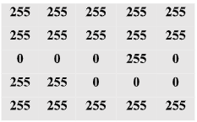

|  |  |  |  |  |
| --- | --- | --- | --- | --- |
|  |  |  |  |  |
|  |  |  |  |  |
|  |  |  |  |  |
|  |  |  |  |  |

image2 in a bitmap:

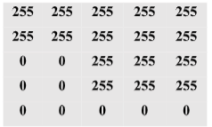Since Mapper function accepts input stored in files, the bitmap images are required to be converted to String format, to supply input as text. String format of images are defined as each pixel column separated by a comma ’,’ character and each pixel row is separated by a semicolon ‘;’ character.

String format representation of image1:

“255,255,255,255,255;255,255,255,255,255;0,0,0,255,0;255,255,0,0,0;255,255,255,255,255”

String format representation of image2:

“255,255,255,255,255;255,255,255,255,255;0,0,255,255,255;0,0,255,255,255;0,0,0,0,0”